

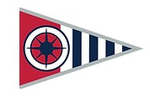**Opening Weekend of Boating Season!**

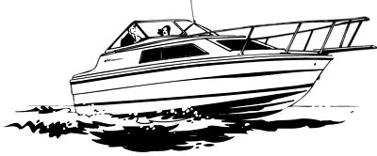 **May 3 - 4, 2025**

**Oak Harbor Marina**

* Travel by boat or travel by car!
* Be a part of our club’s “Shake Down” cruise and get things ship-shape for the upcoming boating months.
* Join us & members from the Deception Pass squadron for a joint rendezvous dinner at Orlando’s BBQ in Oak Harbor at 4pm.
* Make your boat slip reservations directly with Oak Harbor Marina.
* RSVP by April 29th to Susan at [activities.boatsnoco@gmail.com](mailto:newfy03@gmail.com?subject=Fall%20Conference). Head count required for restaurant reservations.